# Get Started with Python

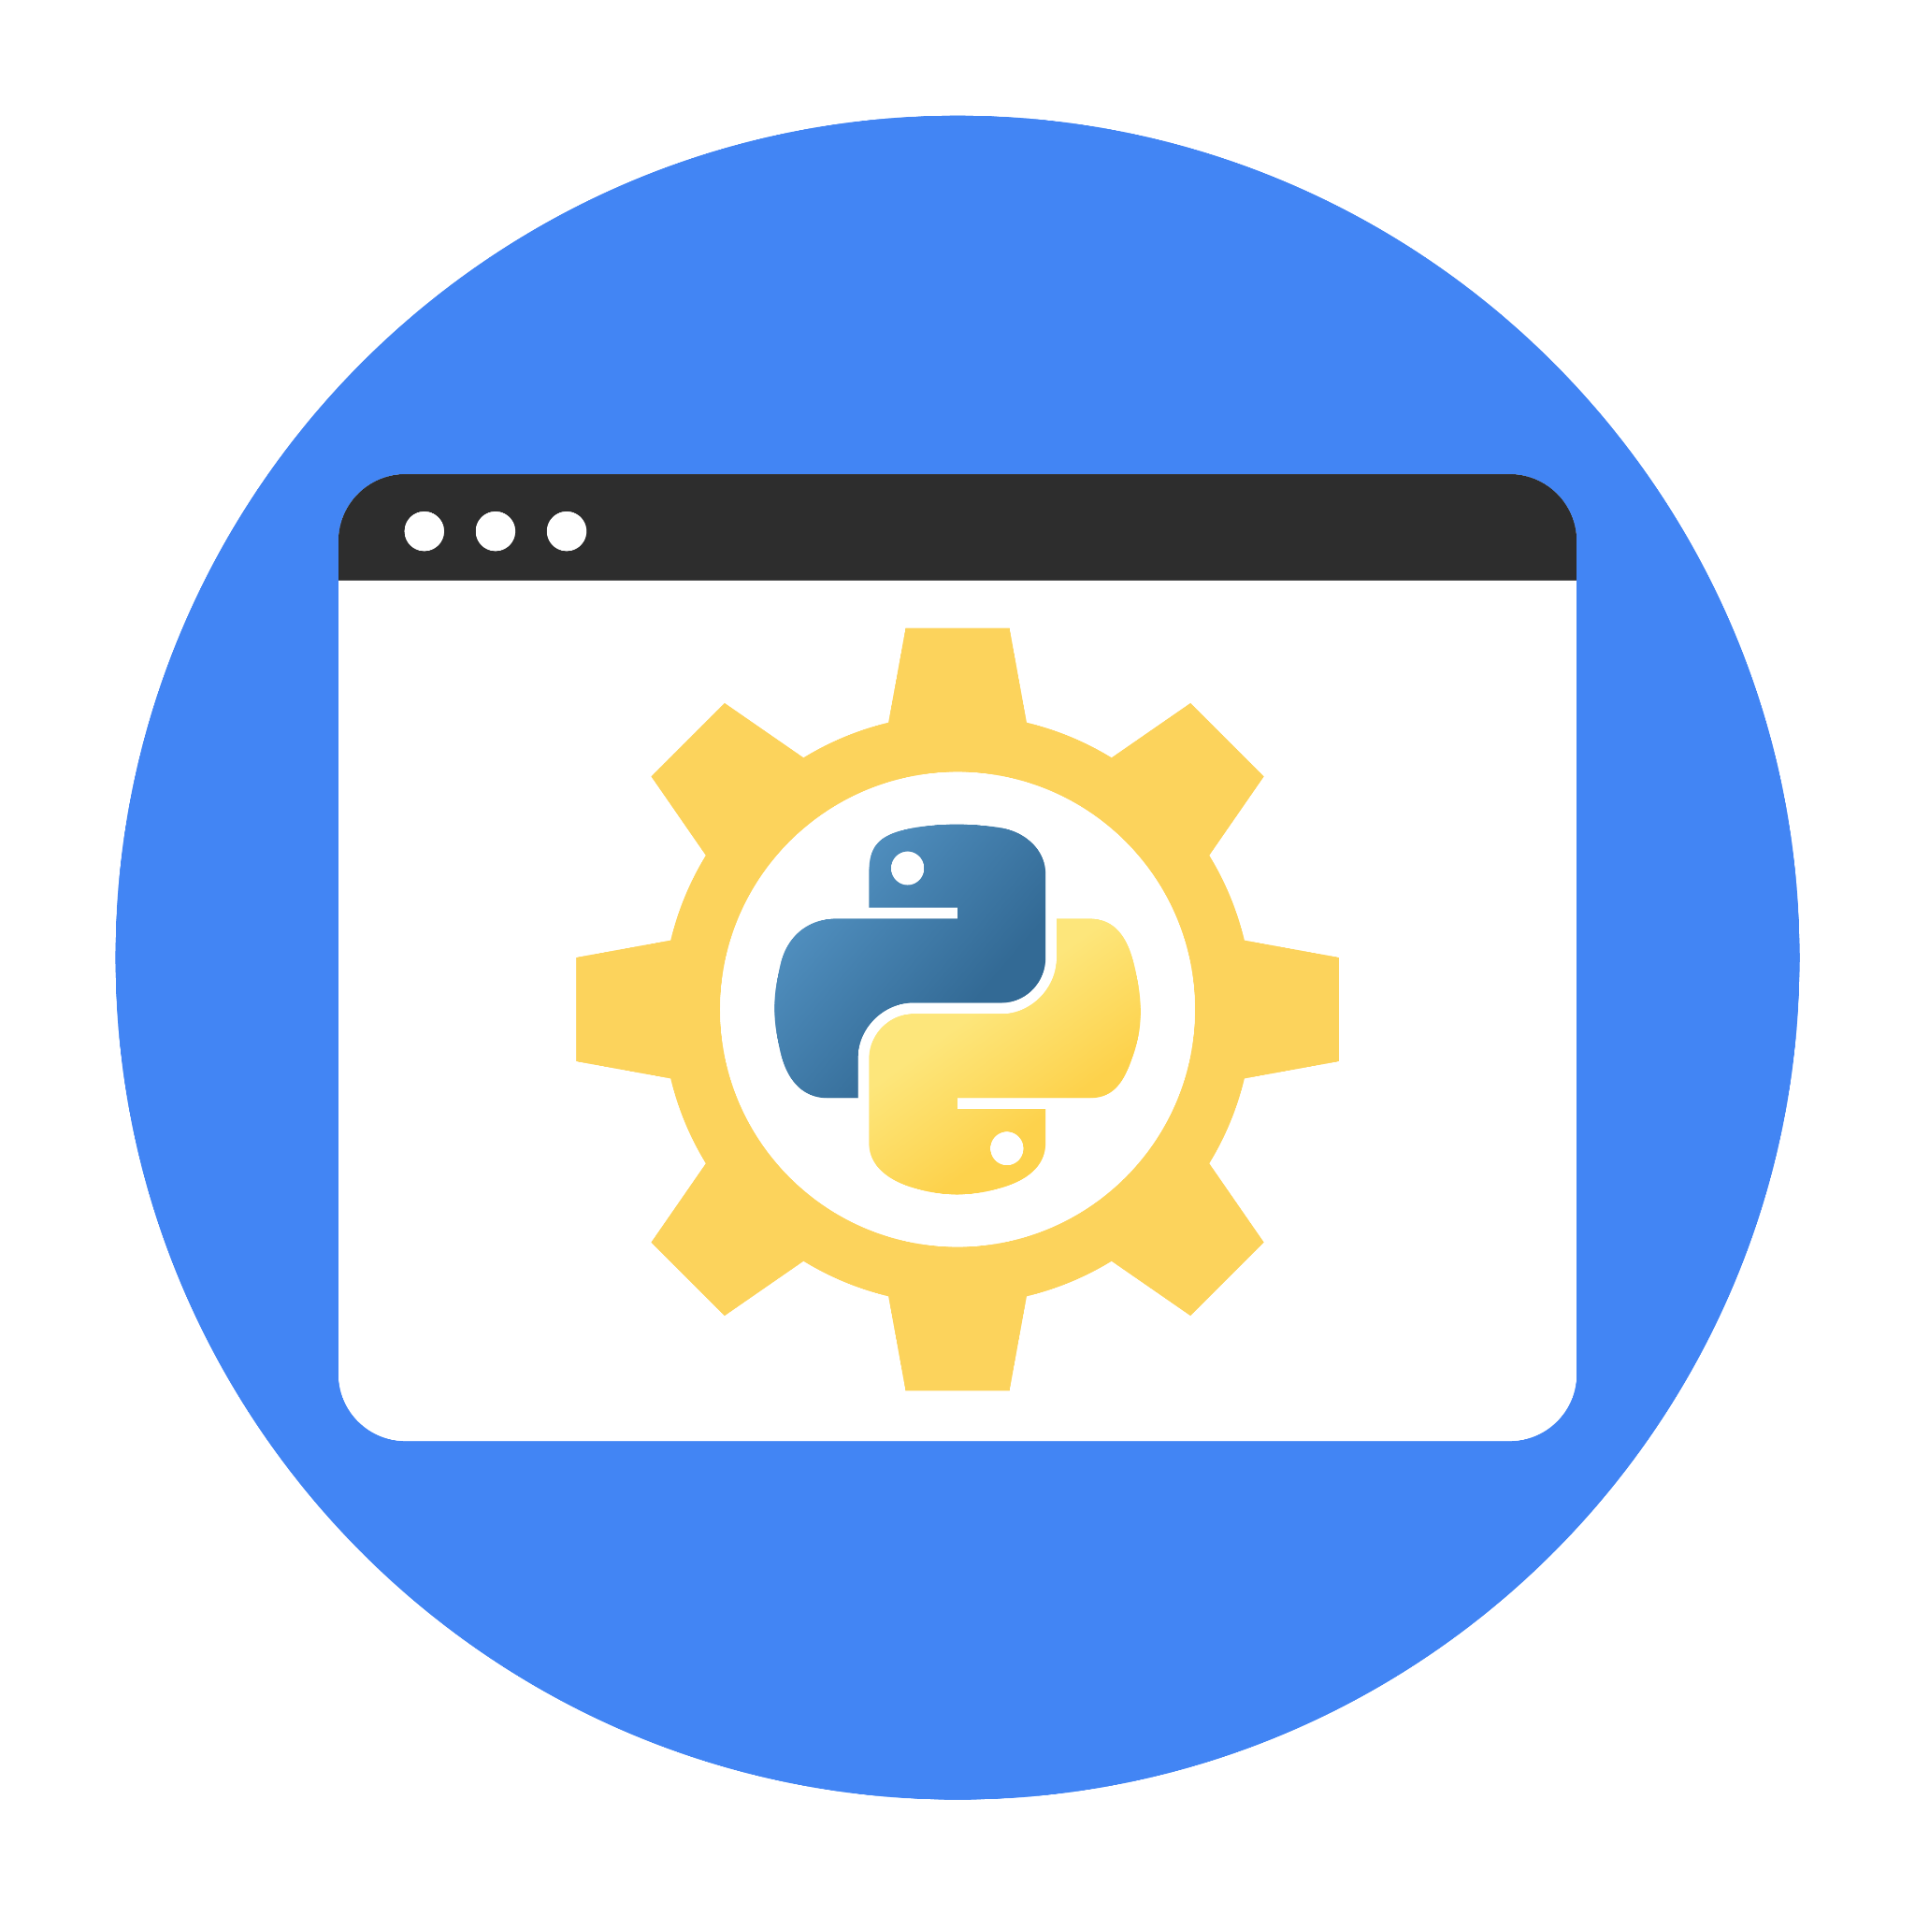

# Instructions

Use this PACE strategy document to record decisions and reflections as you work through the project. You can use this document as a guide to consider your responses and reflections at different stages of the data analytical process. Additionally, the PACE strategy documents can be used as a resource when working on future projects.

# Course Project Recap

Your goals for this project are:

* Complete the questions in the Course 2 PACE strategy document
* Answer the questions in the Jupyter notebook project file
* Complete coding prep work on project’s Jupyter notebook
* Summarize the column Dtypes
* Communicate important findings in the form of an executive summary

**Reference Guide**

This project has three tasks; the visual below identifies how the stages of PACE are incorporated across those tasks.



**Data Project Questions & Considerations**

**PACE: Planning Stage**

* How can you best prepare to understand and organize the provided information?
* What follow-along and self-review codebooks will help you perform this work?
* What are some additional activities a resourceful learner would perform before starting to code?

**PACE: Analyzing Stage**

* Will the available information be sufficient to achieve the goal based on your intuition and the analysis of the variables?
* How would you build summary dataframe statistics and assess the min and max range of the data?
* Do the averages of any of the data variables look unusual? Can you describe the interval data?

**PACE: Constructing Stage**

Note: The Construct stage does not apply to this workflow. The PACE framework can be adapted to fit the specific requirements of any project.

**PACE: Execute Stage**

* Given your current knowledge of the data, what would you initially recommend to your manager to investigate further prior to performing exploratory data analysis?
* What data initially presents as containing anomalies?
* What additional types of data could strengthen this dataset?